Proclamation

WHEREAS, the aim of Children’s Environmental Health (CEH) Day is to raise awareness about the importance of clean air and water, safe food and consumer products, and healthy environments to children’s health and development; and

WHEREAS, CEH Day was created by the Children’s Environmental Health Network and celebrated for the first time on October 13, 2016; and

WHEREAS, CEH Day is observed on the second Thursday in October as a means to celebrate progress of the children’s environmental health movement and create a strong network of child health advocates; and

WHEREAS, CEH Day is a national effort supported by individuals, non-profit organizations, and government agencies; and

WHEREAS, CEH Day encourages individuals and organizations to raise awareness and understanding of children’s environmental health issues, seek improved protections for children, and to perform acts of sustainability or environmental health wellness; and

WHEREAS, together, we can safeguard the health, safety and wellbeing of our most precious resource: children;

THEREFORE; I, MayorName, Mayor of the City of CityName do hereby proclaim Thursday, October 10, 2019 as:

CHILDREN’S ENVIRONMENTAL HEALTH (CEH) DAY

in CityName and urge all citizens to observe this day with awareness-raising and environmental health and stewardship activities to create a healthier environment for our children.

IN WITNESS WHEREOF, I have hereunto set my hand and caused the Great Seal of the City of CityName to be affixed this _____ day of ______, 2019.
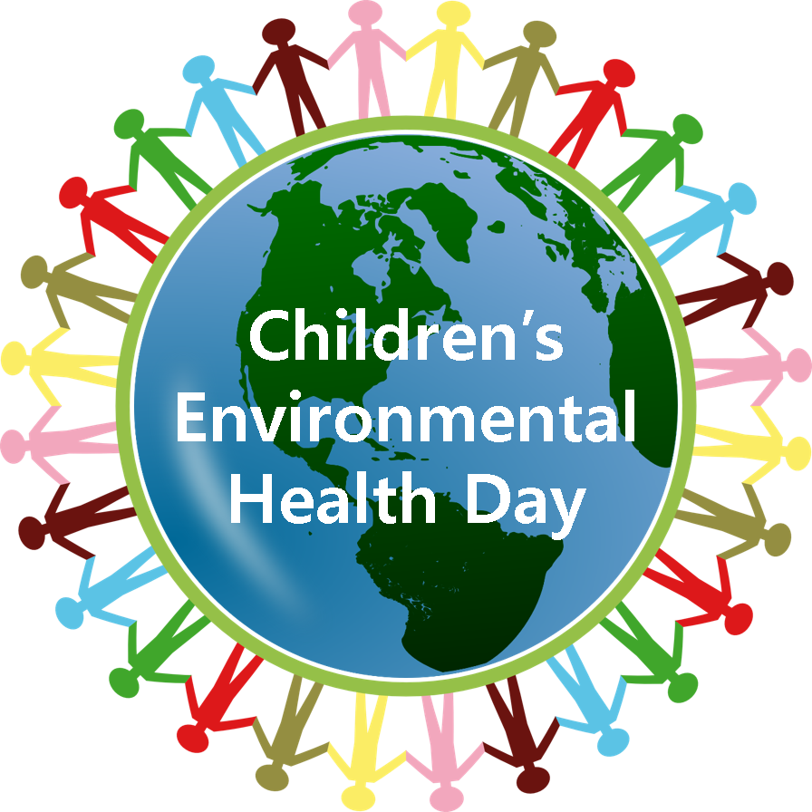

Mayor Name
Mayor, City of CityName

